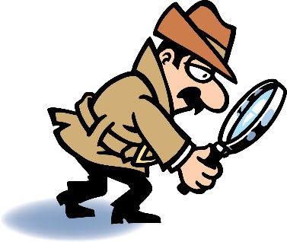**Digraph Detectives**

Name:

|  |  |  |  |  |
| --- | --- | --- | --- | --- |
| ch | sh | th | wh | ck |

whiz

fox

rash

rich

nut

bath

sun

thick

luck

gas

him

neck

path

lab

quiz

rack

whip

wish

dip

chop